Auckland Year 9 & 10 Invitational 7’s Tournament
2024
______________
Bruce Pulman Park
Friday 15th November 2024

Introduction
Welcome to Bruce Pullman Park for the Inaugural Auckland Year 9 & 10 invitational 7’s Tournament. This Tournament has proudly been organised by Auckland Rugby in conjunction with New Zealand Rugby & School Sport NZ. We hope all enjoy the day ahead.

Coaches/Managers Meeting
Can you please be onsite for the Coaches & Managers meeting scheduled for 8:30am. This will be your only window to ask the organisers questions and firm up the draw with any last-minute changes. Questions for referees will also be answered in this time.

Toilets & Rubbish
Toilets both male and female are in the Changing Rooms. Please see us for rubbish bags.

Tents
Schools are welcome to bring tents or gazebos along for shade and cover. These must be pegged down or weighted as part of our health and safety procedures. Please speak to us if you have any concerns.

Food/Beverages
Food trucks will be available on the day with a variety of food and beverages.

Parking on site
There is limited parking on site – vehicles must NOT park in designated training/warm up areas or in the restricted areas which are highlighted in the diagram below.
Vehicles must also be clear of any emergency exits and access to fields. This includes parking on grass space.

Tournament Rules

Player Eligibility and Team Lists:
As per ASSRU Competition Regulations, all players must be:
- Enrolled and attending Secondary School
- Under 15 as of January 1st in year of competition
- Have completed an NZR Player Registration form via Sporty - any players that were not registered for a school team in 2024 (i.e., league players) will also need to complete this before taking part.
- All players must be listed on the official team sheet.
- Any changes to this list of players must be given to the tournament officials at the coaches/managers briefing on the day.

Number of Players:
- Maximum squad of fourteen (14) players
- Twelve (12) only can be used for any one game.
- Players are to be in numbered jerseys
- Each player must wear their allocated number for the entire tournament. (Unless destroyed)

Points:
In each pool match, two points will be awarded for a win, one point per team in the event of a drawn match.

Tied Teams Formula:
If on completion of the pool matches two or more teams in their respective pool have the same aggregate number of points awarded, their final ranking will be determined in accordance with the following formula in order of sequence:
- The team with the most wins
- The winning school of the match already played between the two schools shall be declared the winner.
- If the two schools concerned had drawn the match indicated, the team, which had scored the most tries in all games, shall be declared the winner.
- If this is equal, the team, which has the highest differences of points ‘for’ minus points ‘against’ in their pool matches, shall be the winner.
- Where there is still a tie, the winner shall be declared by the toss of a coin.

Match Duration:
The duration of all matches (finals included) will be seven (7) minutes each way with a one-minute interval. The timing of the tournament allows for a twenty-minute time-period for pool matches to cover over-run, half-time and change-over from one game to another.
A siren will be sounded to commence each round – all other timings (end of half/start of half & full-time) will be determined by the referee.

Finals – The final will be 7min per half for both boys and girls
Drawn Games:
Pool Play = No extra time.
Play-off Matches:
- One half of 7 minutes “Golden Point”.
- The first team to score any points during the extra time period will be declared the winner.
- A coin-toss will determine who kicks off.

If no points are scored at the conclusion of extra time, the formula used to
determine the winner will be in the following order:
- Team who scored most tries in the match
- Team who scored the first try in the match
- Team that scored the first points in the match
- Toss of Coin

Player Substitutions:
- A team can substitute Six players from the game 12 in each game. This mean’s one player may come off and go on again. But you still only have 12 in the game 12.
- Substitutions can only be made during a break in play and only through the referee or touch judge by handing in a sub card.
- Normal substitution rules apply. There are no rolling subs

Disciplinary Procedures:
Any on or off field matters arising will be dealt with by the event organisers.
- One yellow card results in a 2-minute sin-bin.
- Two yellow cards in the same match will result in a red card
- Three yellow cards in separate matches will result in the player not being permitted to take any further part in the tournament and may be required to appear before the Auckland Judiciary.
- One red card results in the player not being permitted to take any further part in the tournament and may be required to appear before Auckland Judiciary.

Playing Rules
The Blues Region U15 7s is played in accordance with IRB & NZR “Laws of the Game” incorporating the Domestic Safety & 7’s Law Variations where applicable.

Key 7s rules include:
- Scoring team kicks off
- A kick off that does not travel past the opposing 10m line will result in a free-kick at the centre of the half-way line to the opposition.
- A kick off that goes out on the full will result in a free-kick at the centre of the half-way line to the opposition.
- A kick off that goes dead or grounded in the in-goal area by the opposition will result in a free-kick at the centre of the half-way line to the opposition.
- Girls will play non-contested scrums. (line outs ARE contested)

Tournament Structure – Boys Premiership

Tournament Structure – Girls Premiership

Tournament Structure – Boys Championship

Tournament Structure – Girls Championship

Venue: Bruce Pullman Park, 90 Walters Road, Takanini 2112
*Please note – there is limited parking space* -

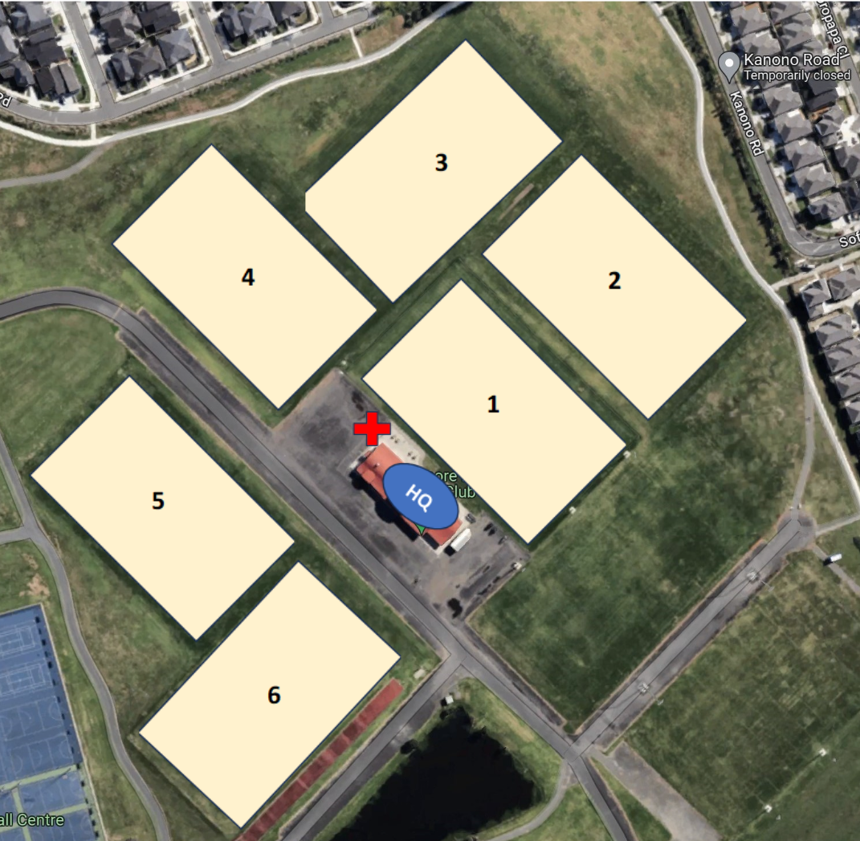

Pools

Draw:
Teams are expected to head to the allocated field at least 5mins before kick-off is scheduled.

Auckland Rugby Contacts
We hope you enjoy the day and wish all our teams the best of luck.
For any further queries please contact:
Eamon Reily – 027 1800 4727 or email – eamon.reily@aucklandrugby.co.nz

